CCD DATA DOCUMENTATION & RESEARCH QUESTIONS

Fact Check & Review Tracker CCD 2025-2026

On background
ArcGIS was used to geocode the geographic coordinates of licensed child care centers and family day homes based on administrative data collected from each state. This data typically includes full address information (e.g., 123 ABC Road, Virginia Beach, VA, 23454). In some cases, however, we only have partial location details, such as city, county, or ZIP code. All address information is processed using the 2025 version of the ArcGIS World Geocoding Service. ArcGIS returns geographic coordinates (latitude and longitude) for each record, along with metadata describing the quality of the match.

ArcGIS provides a key piece of information for each geocoded record:
- Match Level: Indicates the geographic resolution at which the location was matched. Common match levels include:
  - PointAddress: rooftop-level match to a specific address point
  - StreetAddress: interpolated location along a street segment
  - Postal: centroid of the ZIP code
  - Admin: centroid of a broader administrative area such as city or county

When full address information is unavailable, ArcGIS attempts to match the record at the most precise level possible given the available input. For example, if only ZIP code information is available, the result may be geocoded to the ZIP code centroid. For both the Head Start and Public School Pre-K facilities, we rely on the geocodes provided by the federal government.

Generating Local Access Measures.

Family-centered measures of access to early care and education - ScienceDirect

Using centroids of q-mile hexagons within metro areas and centroid of the 1-mile hexagons in non-metro areas, we calculated the access measure for each hexagon centroid
- Used regularly shaped hexagons (q-mile for metro, 1 mile-side for non-metro), as a unit of analysis commonly used in the environmental science and geography fields.
- An issue in the conversion from block-group level data to the hexagonal grid is that boundaries from the two layers don’t necessarily align. There are two cases where block groups, likely in rural parts of the state, contain multiple hexagons, whereas cities have small block-groups that contain multiple block- groups. In converging the information from block-group to hexagonal grid, we use area information from all the polygons created from the overlaying two layers to (dis)aggregate the number of children proportional to the size of area within the boundary of the upper geographic-level.
- Transformation preserves the total number of children under age 5 in the U.S. (2.28 mil in 2023).
For each hexagon centroid, identify providers (N = 225,952) located within a 30-mile straight-line distance using the neartable tool in ArcGIS. (N ≈ 2.6 billion pairs).
- Calculated drive-time distance with OSRMtime command in Stata.
- Two-stage catchment area method (demand-adjusted supply) is calculated:
  - Count the number of children within a 20-minute driving-time radius of each provider j
  - Divide the capacity of provider j by the total number of families located within 20 minutes of provider j (capacity-to-population ratio)
  - Sum all capacity-to pop ratios for providers within the 20-minute driving time radius of each family i (this sum is the demand-adjusted supply)
- Distance-decay function applied; nearby providers are weighted higher.

Synthetic family locations.
Density of families with children under age 6 is derived from 2023 ACS 5-year estimate block-group-level-data
  - Updated data files from Lee, Sojourner display all children up to age 5 (not just families with own children) – preserves estimates of all possible children in need of care, including children living with grandparents, foster care, etc. and in families where one or more parents might not be working.
  - Synthetic points are generated from a 10% sample, randomly placed within block-group boundaries after excluding block groups in uninhabitable areas (e.g., lakes, rivers, state, national, or local parks, airports).
  - Dots on the map are distributed approximately where children under age 6 live; each dot represents about 10 children; actual family locations are not shown – only simulated locations.
- In the data file → values represent access for synthetic families with children under age 6 at each hexagon centroid

 | Column Header | Type | Description
1 | longitude | numeric | Angular measurement, vertical (decimal degrees, WGS84)
2 | latitude | numeric | Angular measurement, horizontal (decimal degrees, WGS84)
NOTE: columns 1, 2 combined refer to a single synthetic family, representing 10 families in a given hexagon, using a family-centered drive-time distance methodology

All supply variables are calculated using the two-stage catchment-area method with 20-min driving-time radii & distance-decay weighting (see Davis, Lee, & Sojourner, 2019)
3 | state_fips | string | Two-digit numeric code defined by NIST to uniquely identify U.S. states, District of Columbia
4 | state_name | string | Full state name
5 | state_abbrv | string | Two-letter state name abbreviation
6 | county_fips | string | Five-digit numeric identifier for U.S. counties; comprised of 2-digit state code and 3-digit county code
7 | county_name | string | Full county name
8 | schooldistrict_code | string | School district identifier (e.g., NCES code).  Interpretation of School District Codes and Code Manual Table Descriptions
9 | sd_name | string | School district name
10 | adj_supply | numeric | Total demand-adjusted child care supply index (all provider types combined, slots per synthetic family)
11 | adj_supply_fcc | numeric | Demand-adjusted supply index for family child care (home-based licensed child care providers)
12 | adj_supply_ccc | numeric | Demand-adjusted supply index for child care centers
13 | adj_supply_hs | numeric | Demand-adjusted supply index for Head Start programs
14 | adj_supply_prek | numeric | Demand-adjusted supply index for pre-kindergarten programs

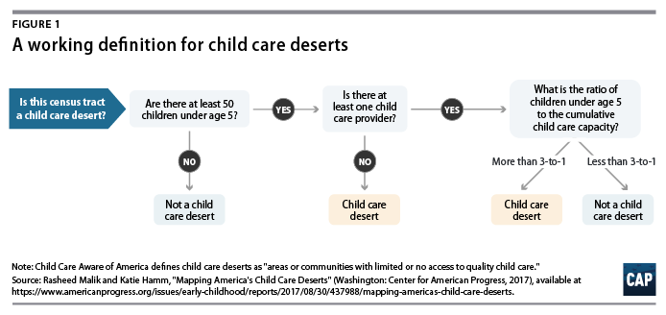

For Report - KEY DATA POINTS
- Percent of total observations that qualify as deserts
  - National breakdown
- State breakdown
  - Degree of scarcity
- Poverty estimate, as relevant
- Breakdowns by race/ethnicity
  - Majority Hispanic/Latino
  - Majority Black, non-Hispanic
- Rural estimates
- Head Start estimates
  - Prevalence
  - Breakdown by geography

